**Following source ids having same structure**

|  |  |
| --- | --- |
| SOURCE ID | BASED URL |
| 78173499 | https://www.jstage.jst.go.jp/browse/fstr/list/-char/en |
| 78209199 | https://www.jstage.jst.go.jp/browse/jjpsy |
| 78333899 | https://www.jstage.jst.go.jp/browse/taesj/list/-char/en |
| 78334999 | https://www.jstage.jst.go.jp/browse/ijsmer/list/-char/en |
| 78337199 | https://www.jstage.jst.go.jp/browse/jact/list/-char/en |
| 78465699 | https://www.jstage.jst.go.jp/browse/ejssnt/list/-char/en |
| 78565499 | https://www.jstage.jst.go.jp/browse/jjhg/list/-char/en |
| 78643299 | https://www.jstage.jst.go.jp/browse/jssst/list/-char/en |
| 78645999 | https://www.jstage.jst.go.jp/browse/jieij/list/-char/en |
| 78651499 | https://www.jstage.jst.go.jp/browse/ieejsmas/list/-char/en |
| 78651599 | https://www.jstage.jst.go.jp/browse/ieejpes/list/-char/en |
| 78651699 | https://www.jstage.jst.go.jp/browse/ieejias/list/-char/en |
| 78651799 | https://www.jstage.jst.go.jp/browse/ieejeiss/list/-char/en |
| 78651899 | https://www.jstage.jst.go.jp/browse/ieejfms/list/-char/en |
| 79159599 | https://www.jstage.jst.go.jp/browse/jiep/list/-char/en |
| 79614699 | https://www.jstage.jst.go.jp/browse/hsj/list/-char/en |
| 79783099 | https://www.jstage.jst.go.jp/browse/nisshoshi/list/-char/en |
| 80041799 | https://www.jstage.jst.go.jp/browse/jvsj/list/-char/en |
| 263761099 | https://www.jstage.jst.go.jp/browse/ieejjournal/list/-char/en |
| 263761299 | https://www.jstage.jst.go.jp/browse/nano/list/-char/en |
| 263761399 | https://www.jstage.jst.go.jp/browse/aijt/list/-char/en |
| 263761499 | https://www.jstage.jst.go.jp/browse/aijs/list/-char/en |
| 263761599 | https://www.jstage.jst.go.jp/browse/kasai/list/-char/en |
| 263761799 | https://www.jstage.jst.go.jp/browse/nisshoshi/list/-char/en |
| 263761899 | https://www.jstage.jst.go.jp/browse/ece/list/-char/en |
| 263762799 | https://www.jstage.jst.go.jp/browse/aije/list/-char/en |
| 294110799 | https://www.jstage.jst.go.jp/browse/elsj/list/-char/en |
| 300835599 | https://www.jstage.jst.go.jp/browse/iieej/list/-char/en |
| 319823699 | https://www.jstage.jst.go.jp/browse/trol/list/-char/en |
| 642412736 | https://www.jstage.jst.go.jp/browse/mta/-char/en |
| 657092723 | https://www.jstage.jst.go.jp/browse/tdcpublication/list/-char/en |
| 661922414 | https://www.jstage.jst.go.jp/browse/aquaculturesci/list/-char/en |
| 909864160 | https://www.jstage.jst.go.jp/browse/sptj/list/-char/en |
| 915617107 | https://www.jstage.jst.go.jp/browse/jhps/list/-char/en |
| 921887002 | https://www.jstage.jst.go.jp/browse/denkikagaku/list/-char/en |
| 932089811 | https://www.jstage.jst.go.jp/browse/tropics/list/-char/en |
| 932533439 | https://www.jstage.jst.go.jp/browse/jar/-char/en |

Go to the based url so the landing page will be appear like below

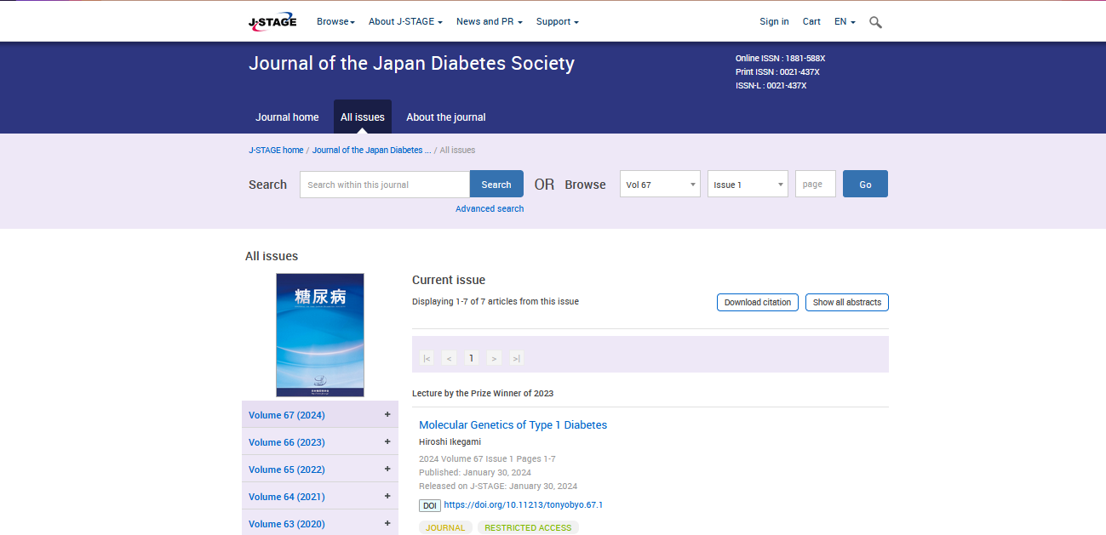

**Select the Current issue from here.**

* **All required articles will be listed here.**

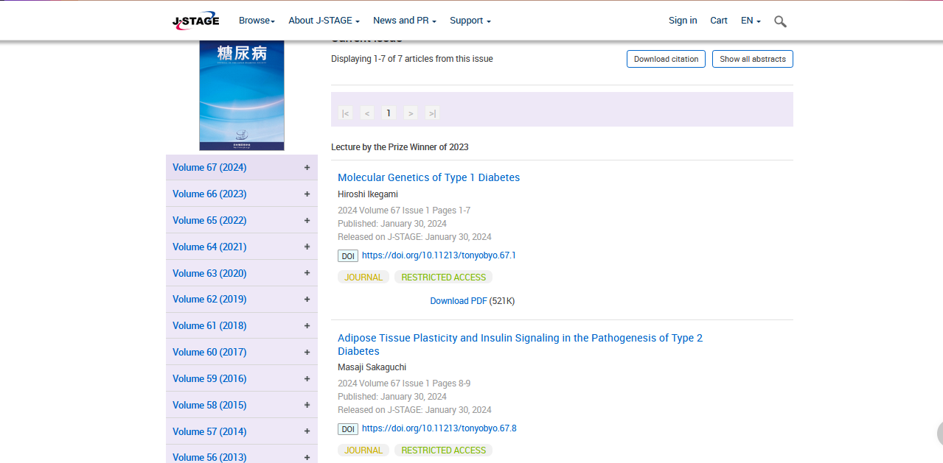

**Meta data can be captured as below.**

**Volume, issue and Year, PAGE RANGE**

* **Click the article name to open the article information page to download the PDF.**

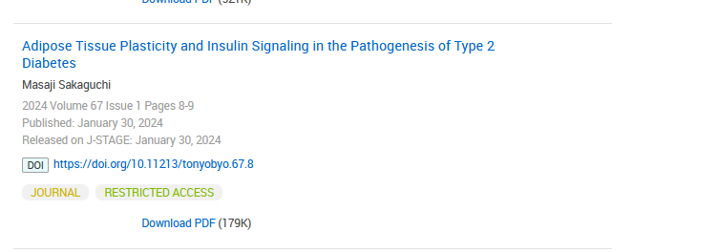

**Article name**

**DOI (start with 10)**

**Click the download link to download the PDF.**

**Page Range**